Work Done
Day 1 Aug. 4, 2017
Beautiful day for flying with the air inuit otter to the camp from Whapmagoostui.
We arrive to the camp and started to install the gears for a confortable camp for 10 days.
Day 2 Aug. 5, 2017
Weather: Blue skies. Wind blowing from the north. Temperature 14°CActivity: We started work at 14:45 hours. Jonas and I went to look for samples on the east end of the lake. We went by 22 footer canoe with a 30 Horsepower outboard motor. We picked up one sample on top of a small hill on the south side of the lake. We then traveled north of the camp. We collected two samples. Sample 2 was collected by the river’s edge. Sample 3 was collected on a hill. We finished work today at 20:00 hours.
Date: Aug. 5, 2017
Sample 2: SHE002
Location: 55 29’ 49.7”
76 16’ 36.7”
GPS Code: 044
Sample 3: SHE003
Location: 55 28’ 57.7”
76 16’ 04.6”
GPS Code: 045

Sample 1: SHE001
Location: 55 29’ 23.4”
76 ’14 34.9”
GPS Code: 043

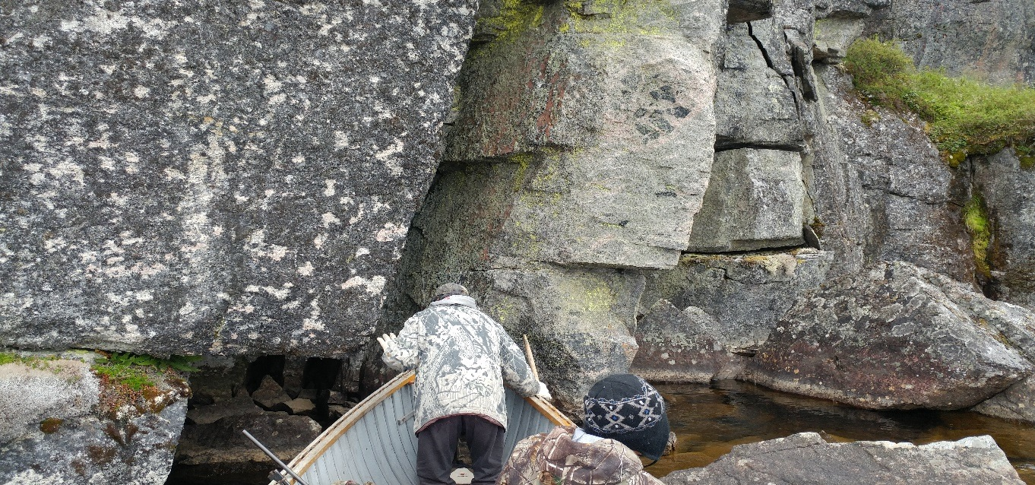
Jonas examining a crevasse
Day 3
Date: Aug. 6, 2017
Weather: Partly cloudy with the winds blowing from the north at 10 km/hr. temp. 15°C.
Activity: We started work at 13:24 hours today. We traveled north to a nearby lake. The going was tough. Thick brush and heavily wood area. We came across a well-trodden black bear trail in the deep woods. We picked up a few samples but not much magnetic properties. We have one sample only.
Date: Aug. 6, 2017
Sample: SHE004
Location: 55 28’ 49.6”
76 16’ 57.4”
GPS Code: 047
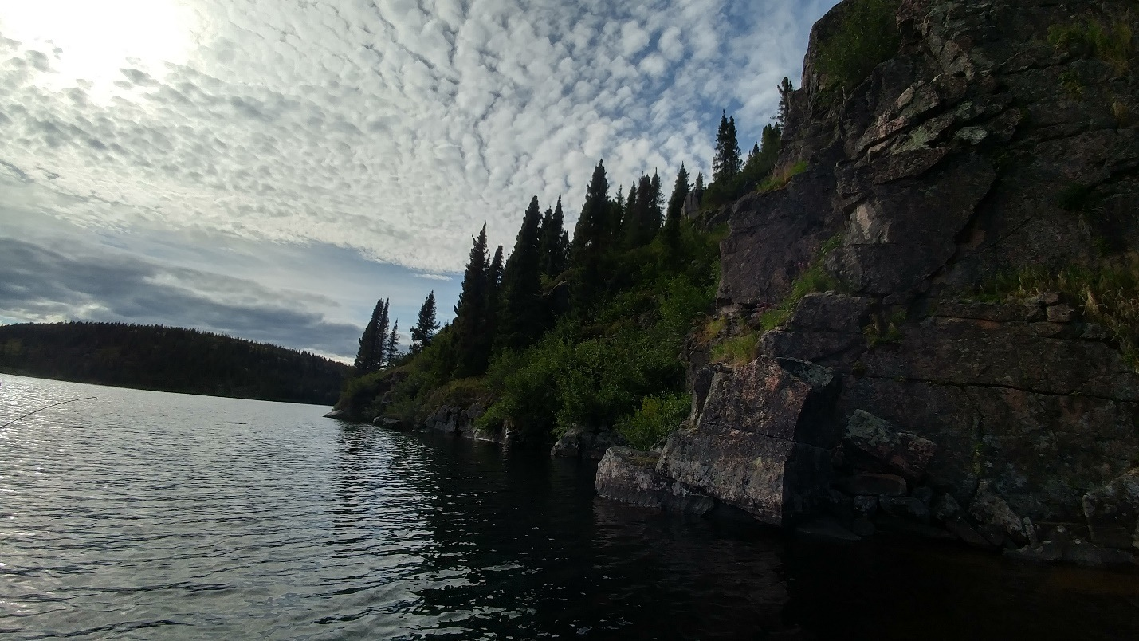
A Lake called Willow Ptarmigan’s Throat Sac

Day 4
Date: Aug. 7, 2017
Weather: Light winds from the west. A few clouds this morning. Temp. 17°C
Activity: This afternoon Jonas and I traveled by four wheelers east of camp. At the mouth of the river we collected one sample with magnetic properties. The terrain is pretty rough for four wheelers. Nonetheless, it was a fun ride.
Date: Aug. 7, 2017
Sample 3: SHE005
Location: 55 30’ 12.4”
76 13’ 27.3”
GPS Code: 046
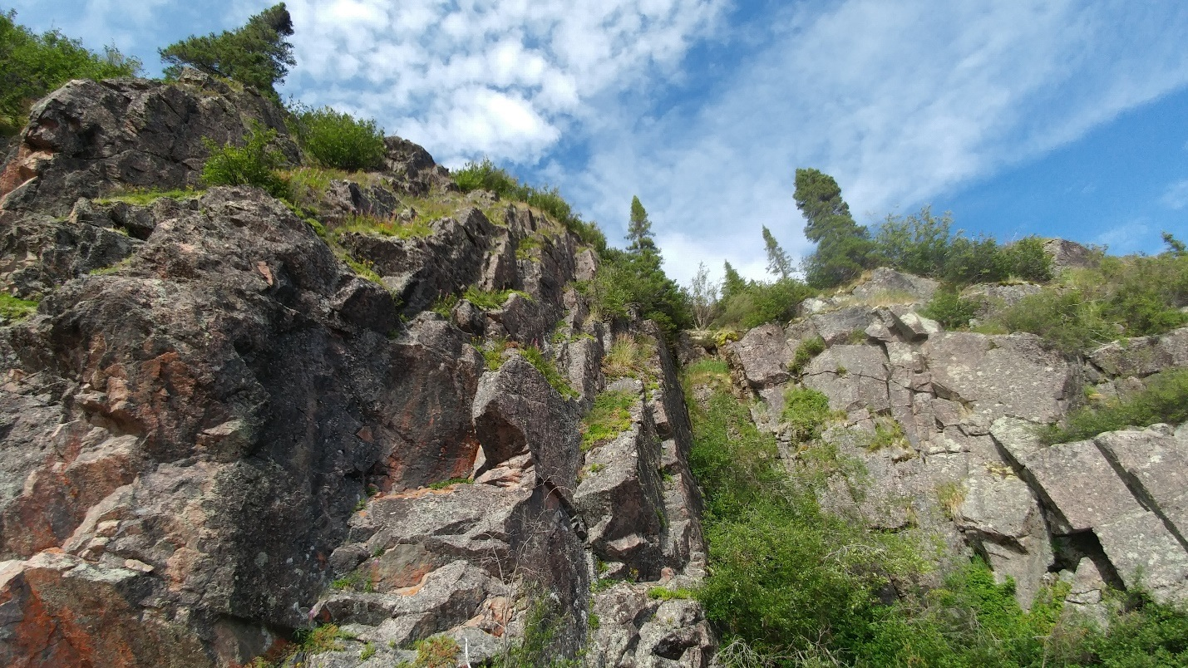
A Cliff where the Osprey nests.

Day 5
Date: Aug. 8, 2017
Weather: Overcast with winds blowing from the west. Temp 12°C
Activity: At 12:30 hours Jonas and I traveled downriver by canoe 15 km west. The area was mostly granite rock. We picked up a few samples but none of them had magnetic properties. We saw a large bold eagle flying along the shoreline. Our guess was that the mighty eagle was fishing. We finished work at 16:31 hours.
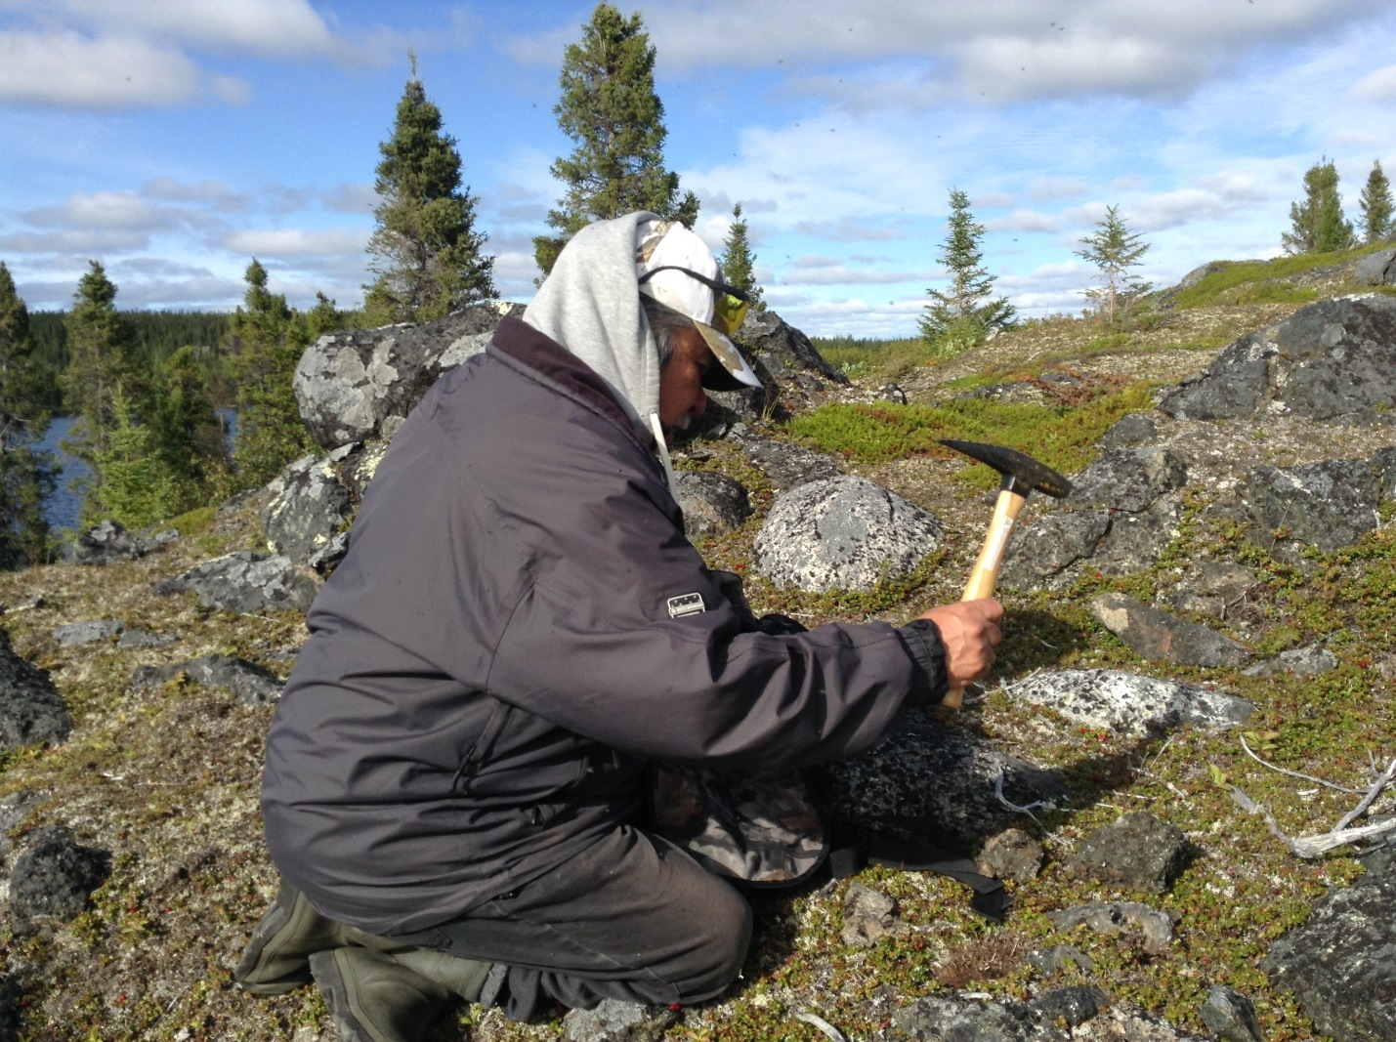
Jonas examining samples.

Day 6
Date: Aug. 9, 2017
Weather
Heavy rain with strong winds. Not an ideal condition to be outing. Temp. 9°C
Activity
We got up at 5 am this morning. But the weather was too bad to head out. The winds were too high to go on the canoe. I got two samples down the river with magnetic properties. The weather is so bad that even all the animals are taking shelter in the deeps woods. Not even the wolves came to feed on food scraps at the camp today.
Date: Aug. 9, 2017
Sample 6: SHE006
Location: 55 30’ 12.4”
76 13’ 27.3”
GPS Code: 046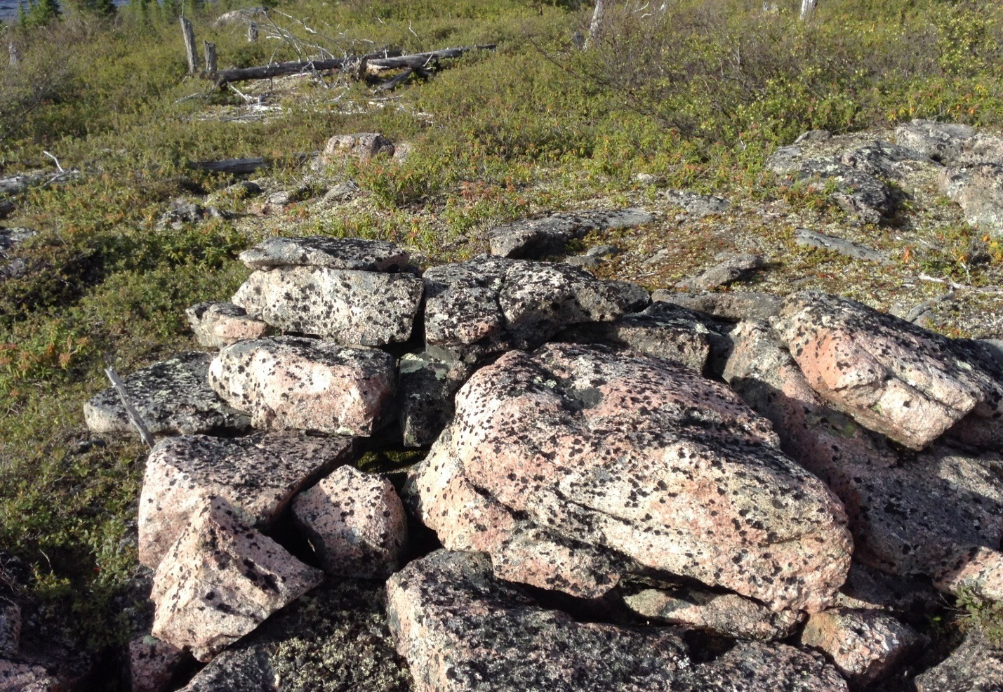
Manmade structure. Ancient Cree dried meat storage

Day 7

Date: Aug. 10, 2017
Weather: Cloudy with a period of showers. Temp. 10°C
Activity : At Jonas and I went east by ATV’s. We got three samples. There were a lot of mosquitos and black flies. Nonetheless, it was fun. We really enjoyed the brilliant scenery. The wilderness here is so vast. There is much to discover. We plan to come back next summer and continue the exploration.
Date: Aug. 10, 2017
Sample 9: SHE009
Location: 55 27’ 38.3”
76 13’ 46.6”
GPS Code: 055
Sample 7: SHE007
Location: 55 27’ 30.6”
76 11’ 24.4”
GPS Code: 052

Day 8
Date: Aug. 11, 2017
Weather: Sunny with light winds from the south. Temp. 15°C
Activity : We went by canoe 12 km west from base camp AT 11:14 hours. We collected one sample by the north side of the lake called Big Island Lake. There was not much to discover. It was mostly granite rock. A saw numerous ducks and loons in the water. We finished the exploration at 14:34 hours and headed back to base.
Date: Aug. 11, 2017
Sample 10: SHE010
Location: 55 29’ 59.3”
76 27’ 04.6”
GPS Code: 056
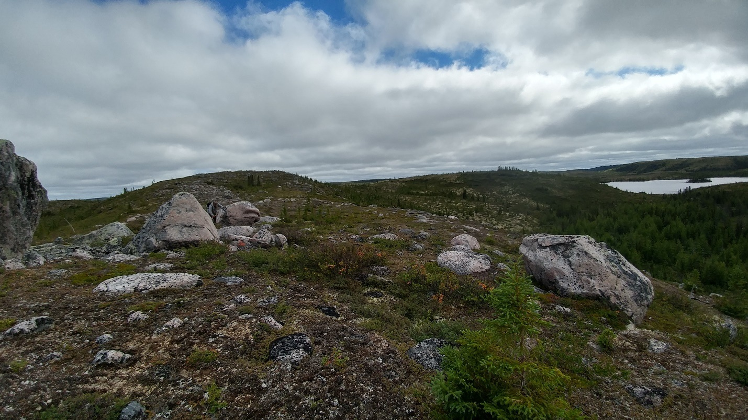
On top of the hill looking eastward at Big Island Lake

Day 9
Date: Aug. 12, 2017
Weather: Sunny with light winds. Temp. 12°C
Activity : 15:00 hours. We traveled 5km east by ATV’s. We collected one black magnetic mineral with a lot of sparkles on the north side of the river. There were a lot of black flies. I think I swallowed a few. Jonas found fish bones on top of a large granite boulder covered with black crispy flakes where an eagle or osprey had dined.
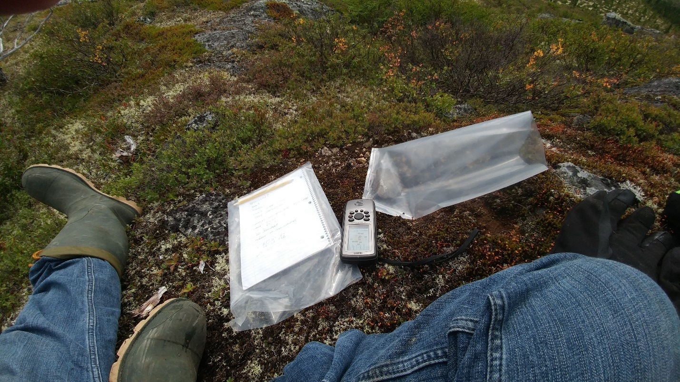
Taking notes and coordinates

Date: Aug. 12, 2017
Sample 11: SHE011
Location: 55 27’ 46.0”
76 11’ 07.7”
GPS Code: 057

Day 10
Date: Aug. 12, 2017
Weather: Overcast with drizzles. Temp. 9°C
Activity : We finished work late yesterday evening.. We are flying back to Whapmagoostui today. We spend the morning putting away the canoes and the four wheelers. We cleaned the cabins and burned the garbage at the dumpsite. The wolves came to visit one last time. They fed on fish scraps and fed their young. A loon can be heard making a lonely cry out on the lake as if it were missing us already.

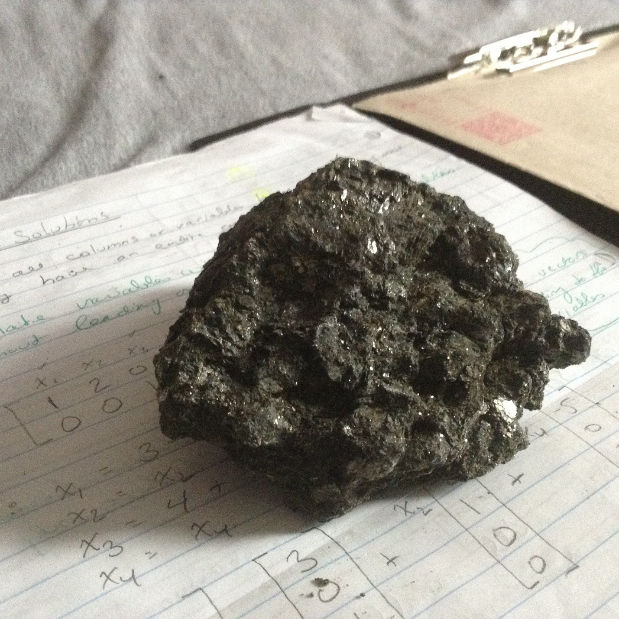
Our last sample. SHE011

We conclude by saying that in overall the project was a success. We collected 11 samples. Most of them are magnetic minerals. Only two do not have magnetic properties. We placed the 11 samples in the sample bags coded “SHE001-SHE011” and the date and location. We plan to come back next summer and do more prospecting. The area is too vast to explore in only 10 days.

